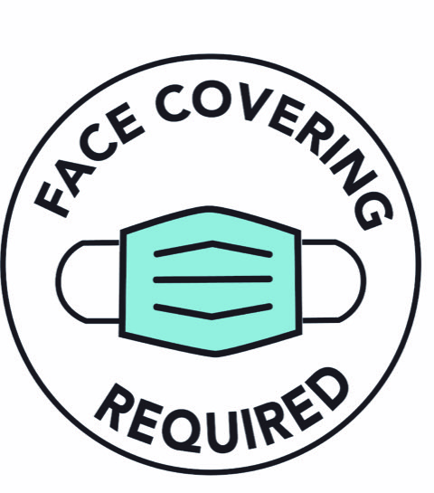

Wear a mask or cloth face covering
It must cover your nose and mouth

